1. Token Management MS - GetPGToken
1.1. Use case 1: Get PG token from DB
1.2. Use case 2: Get PG token from RTMM
1.3. Integration Details
1.4. Headers
1.5. Request Parameters Input
1.6. Input Validation
1.7. Response Parameters
1.8. Get PG Token API Logic
4.1. Error Codes

Token Management MS - GetPGToken
This operation is used to retrieve PG token info.

Use case 1: Get PG token from DB
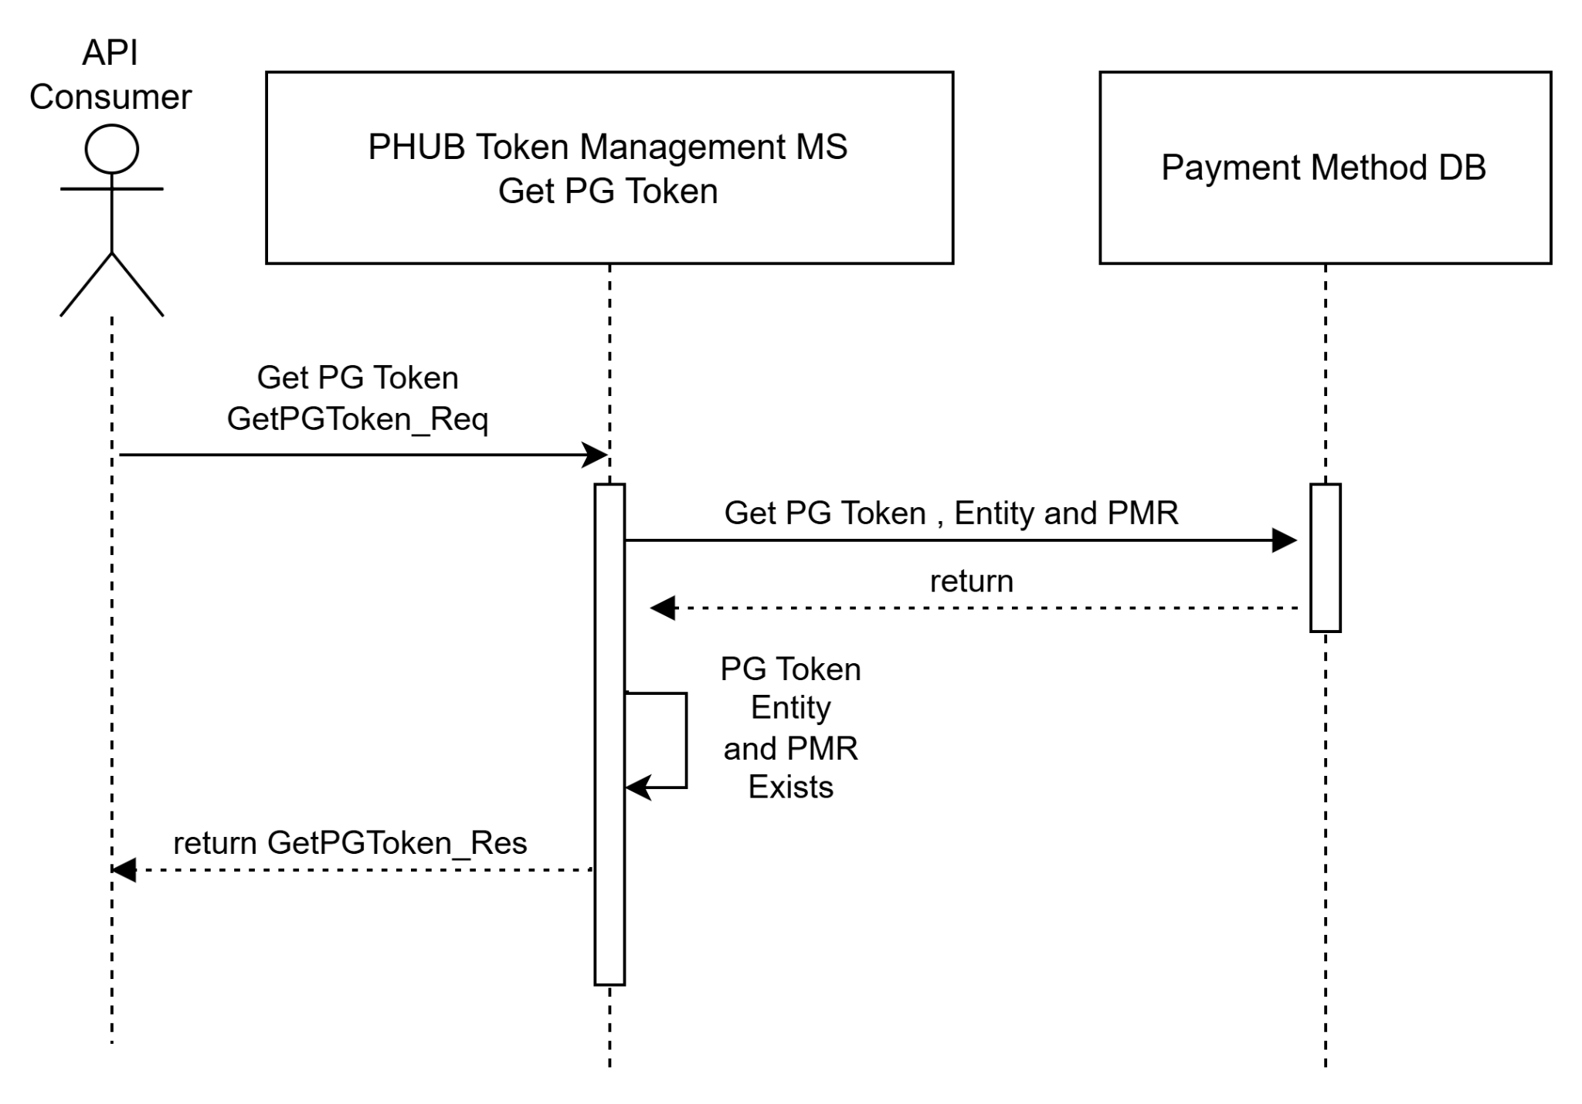

Use case 2: Get PG token from RTMM

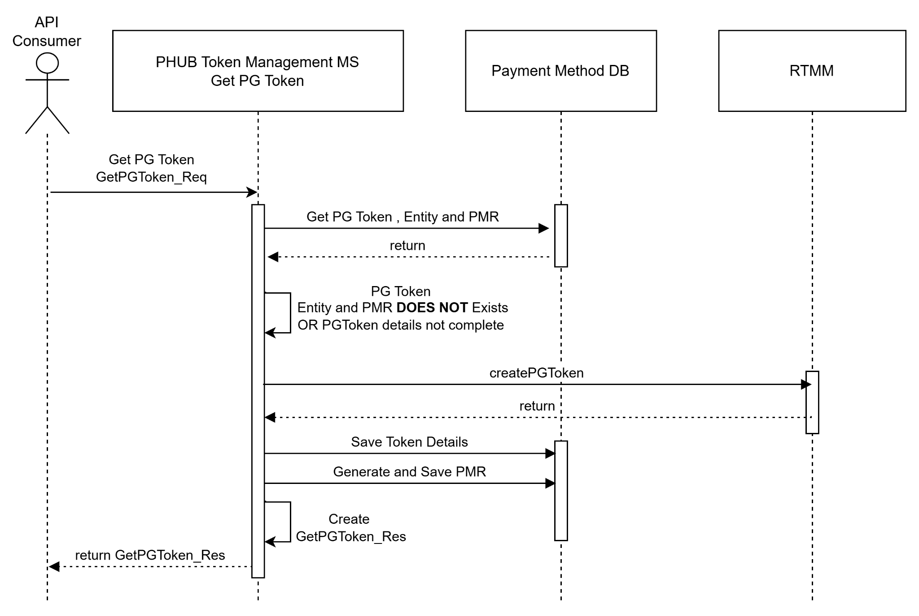

Integration Details
Akamai URL | N/A
APIM URL | Canada Central/East
AKS URL | https://phub1.proda01.aks.rogers.com/api/token-management/v1/pgtoken  https://phub1.prodb01.aks.rogers.com/api/token-management/v1/pgtoken
HTTP Type | POST
Content Type | application/json
Security | N/A

Headers

Name | Mandatory | Example/Type
correlatorId | Y | WINM3f5e8c2a-9b1d-4c3a-8f2a-7e9d2a1c4b6f
Content-type | Y | application/json

Request Parameters Input
***For optional fields, if channel doesn’t have data to fill, please DO NOT send empty/space/NULL values.

Request URL will be logged in app-insights. This is will done by enabling app-insights in APIM in cloud.
Request body will be logged in app-insights by microservice.
All following field names will be under GetPGToken_Req object
Field Name | Description | Sample value | Mandatory | Data Type | Default Value
monerisToken.token | Moneris token  16 digits starting with 9 | 9145678654321 | Y | string
monerisToken.expiryDate | Expiration date of Moneris token. May be expired MMYY |  | Y | string
correlatorId | Unique identifier in the client for the payment method in case it is needed to correlate.  maxLength: 64 |  | Y | string
isValidated | If the payment method has been already validated.  Enum:  [ Y, N ] | Y | Y | string
entityRef.id | Account ID of GUID Up to 36 alphanumeric characters:  for Maestro: Maestro account number  for V21 – BAN  for WinOnline Media – GUID  for SS – CAN  for TSC – customer account number  etc.  Entity (or account), to which payment method is linked, |  | Y | string
entityRef.@referredType | The actual type of the target instance when needed for disambiguation. 1 - Account Number, 2 - GUID |  | Y | string
entityRef.systemIndicator | ID from different backend system | Vision21 | Y | string
channel.id | Source ID (value defined by CASH) - Unique identifier of a Channel. |  | Y | string
channel.businessUnit | minLength: 2  example: WL,FD  maxLength: 2  Line of business (value defined by CASH) | WL | Y | string
channel.merchantPaymentType | minLength: 2  example: OT  maxLength: 2  Merchant Payment Type (value defined by CASH) | OT | Y | string
@type | maxLength: 1  example: 1 = Credit Card/Token,2 = Apple Pay,3 = Google Pay,4 = VI SRC  Type of payment method (e.g.: credit card, bank card, cash, voucher, etc). |  | Y | string

Input Validation
Payment Hub will validate below input from channel and the validation results are added in the log (app-insights)
Field Name | Validation Logic | Error Code | Error Message
GetPGToken_Req.mToken | - Must be present  - Has 16 digits  - Start with 9 | TBD | GetPGToken_Req.mToken is not valid
monerisToken.expiryDate | - Must be present  - Has 4 digits  - Valid year and month | TBD | TBD
entityRef.id | - Must be present  - Must be up to 36 alphanumeric characters | TBD | TBD
entityRef.@referredType | - Must be present  - Has 1 digits  - It should be either 1 or 2 | TBD | TBD
channel.businessUnit | - Must be present  - Has 2 characters  - Must match in reference table | TBD | TBD

Response Parameters
All following field names will be under GetPGToken_Res object
Field Name | Description | Sample value | Mandatory | Data Type
pmr | Unique Identifier of payment method (PMR)
correlatorId | Unique identifier in the client for the payment method in case it is needed to correlate.  maxLength: 64 |  | Y | string
isValidated | If the payment method has been already validated.  Enum:  [ Y, N ] | Y | Y | string
cof.id | example: AGREEMENTID11  Unique identifier of agreement |  | Y | string
cof.type | Type of agreement  Enum:  [ RECURRING, INSTALLMENT, UNSCHEDULED, ONETIME ] |  | Y | string
cof.agreementStatus | a status return to identity agreement is new or existing  Enum:  [ new, existing ] |  | Y | string
entityRef.id | Account ID of GUID Up to 36 alphanumeric characters:  for Maestro: Maestro account number  for V21 – BAN  for WinOnline Media – GUID  for SS – CAN  for TSC – customer account number  etc.  Entity (or account), to which payment method is linked, |  | Y | string
entityRef.@referredType | The actual type of the target instance when needed for disambiguation. 1 - Account Number, 2 - GUID |  | Y | string
entityRef.systemIndicator | ID from different backend system | Vision21 | Y | string
channel.id | Source ID (value defined by CASH) - Unique identifier of a Channel. |  | Y | string
channel.businessUnit | minLength: 2  example: WL,FD  maxLength: 2  Line of business (value defined by CASH) | WL | Y | string
channel.merchantPaymentType | minLength: 2  example: OT  maxLength: 2  Merchant Payment Type (value defined by CASH) | OT | Y | string
@type | maxLength: 1  example: 1 = Credit Card/Token,2 = Apple Pay,3 = Google Pay,4 = VI SRC  Type of payment method (e.g.: credit card, bank card, cash, voucher, etc). |  | Y | string
status | Status of the payment method  Enum:  [ V, D ] |  |  | string
paymentMethodObject.token | example: 9145678654321  Tokenized representation of the card number (created by payment gateway). |  |  | string
paymentMethodObject.expirationDate | example: 1126  Card Expiry date |  |  | string
paymentMethodObject.cardBrand | example: VI (Visa), MC (Mastercard), AX (Amex)  Card network brand |  |  | string
paymentMethodObject.cardLastFour | maxLength: 4  last four digits of the original card |  |  | string
paymentMethodObject.bin | example: 554887  Bank Identification Number - First six of the card |  |  | string
paymentMethodObject.issuer.issuerName | example: Rogers Bank  Name of the card issuer |  |  | string
paymentMethodObject.issuer.issuerCountryCode | example: GBR  The country code of the card issuer, if known. |  |  | string
paymentMethodObject.issuer.cardLevel | example: WORLD ELITE/STANDARD  Card product level or tier |  |  | string
paymentMethodObject.issuer.tags | metadata of issuer details |  |  | string
paymentMethodObject.fundingSource | example: CREDIT, DEBIT, PREPAID  Indicates whether the card is credit, debit, or prepaid |  |  | string
paymentMethodObject.createdDate | PG Token creation date |  |  | string
paymentMethodObject.lastUpdatedDate | PG Token last updated date |  |  | string

Get PG Token API Logic
- If token already exist in PHUB DB, do not invoke "PG Tokenization's createPgtoken service"
- If a token not found in PHUB DB, Invoke PG Tokenization's createPgtoken service through SSG and return the response.
- Update Payment Hub DB
  - PAYMENT_METHOD
  - TOKENIZED_CARD
  - ENTITY_DETAILS
  - ENTITY_PMR_MAPPING
  - PMR_MONERIS_MAPPING
  - TOKEN_ACTIVITY_LOG (if existing token attributes is changed)
- If configured for debug, insert new record to : TOKEN_MIGRATION_AUDIT_LOG

Error Codes
These are the PHUB error codes. HTTP Code 401 Unauthorized is returned at APIM layer and has no PHUB error code associated.

PHUB Error Code | Description | HTTP Error Code
001 | General error. Can be a code and/or database error. | 500 Internal Server Error
002 | Validation error. There are missing/invalid fields in the request payload. | 400 Bad Request
003 | Endpoint does not exist | 404 Not Found
004 | Payment Gateway Error. This is thrown when PG returns an error response, not a failure | 422 Unprocessable Entity

